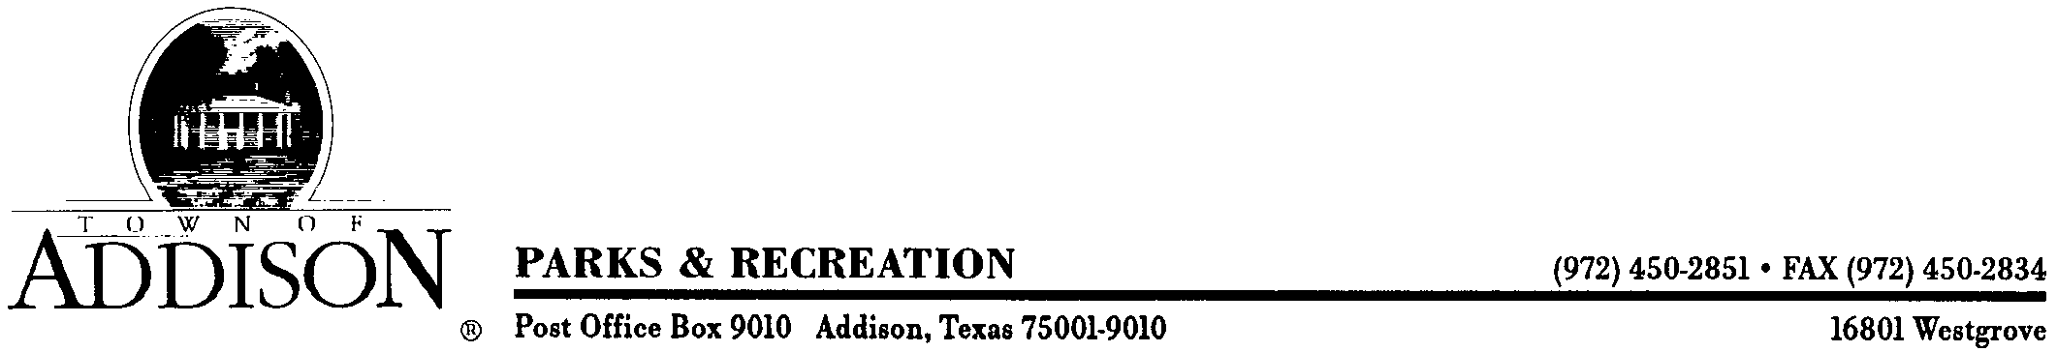

Preliminary Landscape Inspection Report
Methodist Hospital Expansion

April 16, 2013

Plantings:
- Professionally remove suckers, broken limbs, and stubs from all trees
- Remove broken twigs from shrubs
- Pick up trash, debris, loose rock, etc. on entire site
- Replace trees with poorly formed canopies and/or that have been disfigured by damage
- Backfill holes at northeast corner of Addison Rd./Sojourn by traffic signal
- Where needed use soil to level sod; soak and roll to level all sod
- Rework very rough sod installation at northeast corner of Addison Rd./Sojourn; Remove rock, level, repairs ruts, and clean up along sidewalk as well
- Repair ruts
- Lower and cap two exposed above-ground pipes/sleeves at northeast corner of Addison Rd./Sojourn; Appear to be 3” in size
- Finish landscape installation around building and south parking lot
- Clean beds of soil, trash and debris deposited from concrete cleanup
- Finish installation of edging
- Compact decomposed granite
- Complete installation of rock around light pole pier on Dallas Pkwy. frontage
- Replace dead, dying, defoliated, partially defoliated, and/or missing shrubs and trees at the original hospital location
- Note: Due to wind, trees moving in planting pits creating air gaps and loose balls
- Clean up, grade and re-sod area along Addison Rd. frontage north of Sojourn
- Eradicate weeds in turf and tree root balls
- Remove remnants of old tree trunk at southwest corner of south parking lot
- Address drop off at far south end of Addison Rd. sidewalk; Clean up this location as well
- Pull tape and tags from all trees
- Clean up and professionally prune large existing Hackberry tree at northeast corner of south parking lot

Sojourn Medians:
- Replace damaged plants
- Eradicate weeds in turf and tree balls
- Fill in gaps/Plant missing shrubs
- Pick up trash and debris
- Level and roll sod
- Replace any dead sod
- Mulch trees

Irrigation:
In General – Set all heads and valve boxes to grade; plumb all heads; clear all clogs; properly orient spray patterns; use appropriate nozzles to keep water within confines of landscaped areas/throwing of water onto paved surfaces is not acceptable; Per Ordinances install rain and freeze sensors; Use the proper head for the application
Note: Unable to check irrigation as system not complete
Items noticed:
- Nozzles not installed on all heads
- Open ended drip tubing
- Break at tree south of Sojourn; See large hole
- No power to controller south of Sojourn
- Not all heads plumb

Once all items are complete, contact me at 972-450-2863 to re-inspect the property.

Note: No final Certificate of Occupancy will be issued until all items are satisfactorily completed. Thirty (30) days will be allowed for this process.

Call me at the number above if you have any questions.

Ron Lee
Parks Operations Manager, Town of Addison

